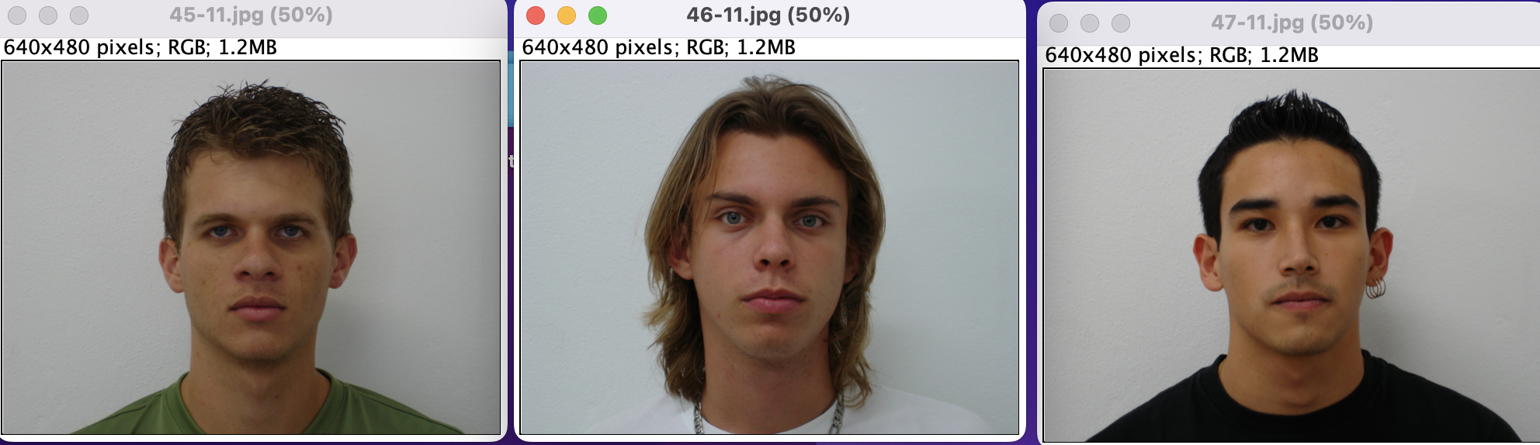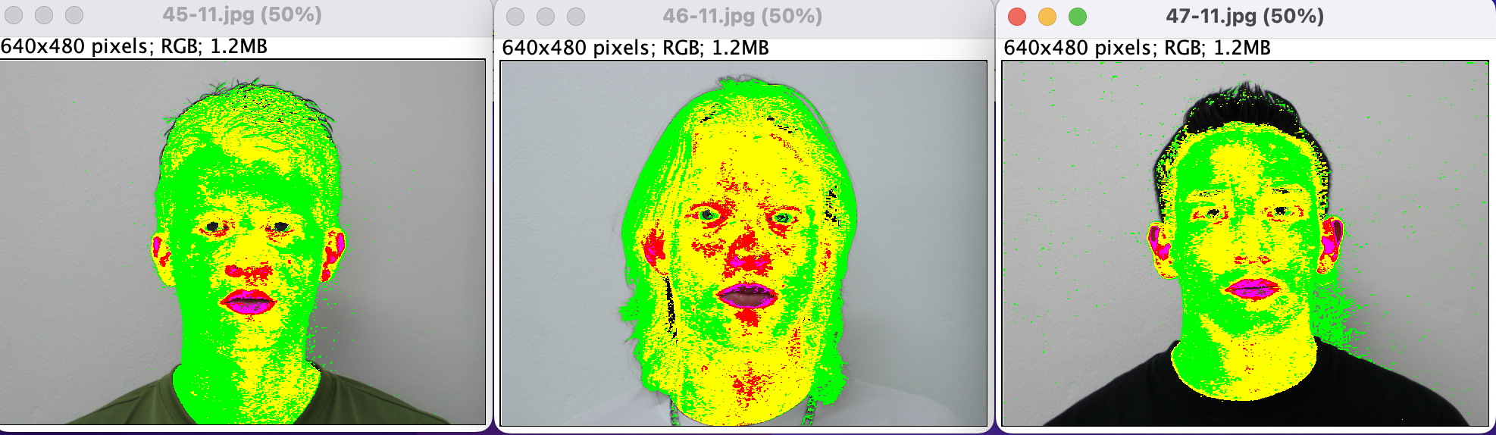  
After applying All_layers plugin we received the following images.  
We can see the colors indicating the facial regions. Green is for face bound, Yellow is for the central part of the face, Red is around the nose and ears and Margrit indicates lips.

After applying the plugin, we can see that those images have so many noises, especially the second one. So let use some filters.

Let’s start applying Gaussian Blur with radius = 5  
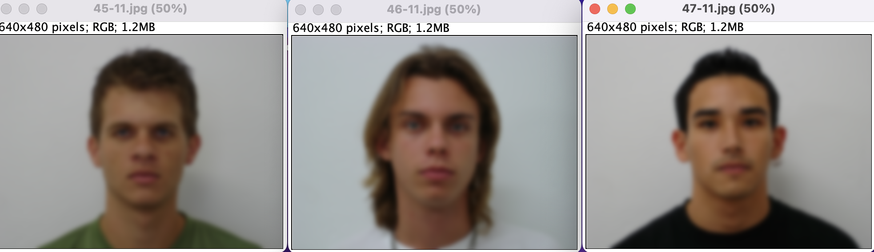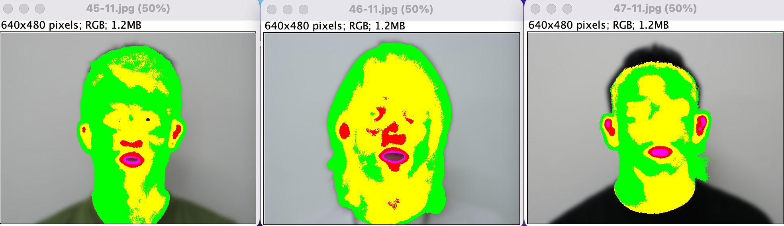  
After applying Gaussian Blur filter and applying the plugin again, we can see that the noise ratio is reduced, and we can see that the second image is still too noisy to detect face parts. But from the first picture and especially the last one, we can see that the noise is too low and we can detect the facial bounds, ears and lips, and center face colored with yellow.

Let’s apply a median with a radius = 5

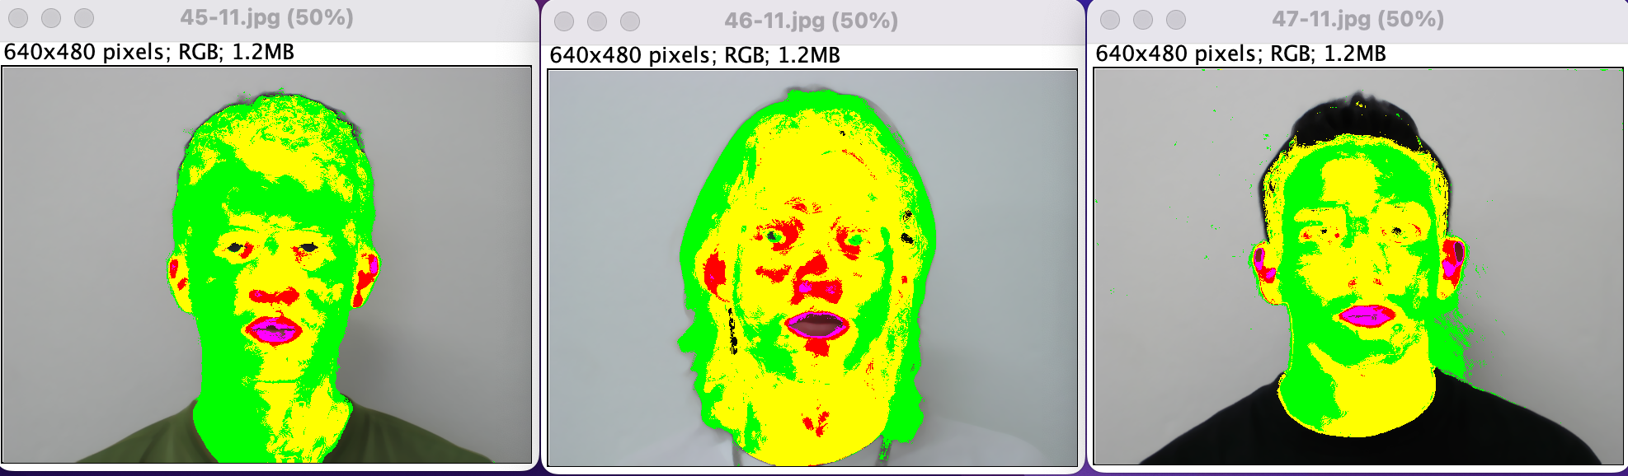

We can see that the second image is still too noisy to detect something. The first image is the clearest to detect ears, lips, face center, and bounds. The last image, it is also somehow detectable but still has a little bit of noisiness.

Let’s apply a mean with a radius = 5

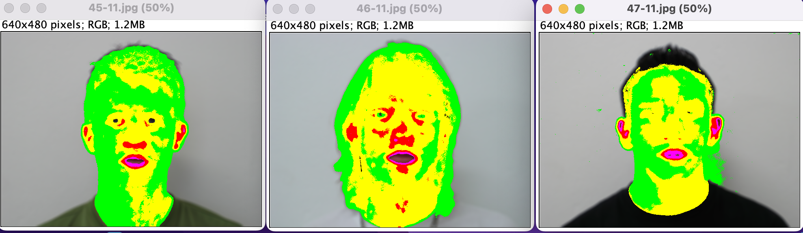

We can see that the second image is still too noisy but it has better results than the median. The first image is the clearest to detect. The last image is also detectable and it has better results than the median.  
  
For the second image, let’s try something else.  
Let’s apply blur with radius = 5 and use Binary_layer plugin.  
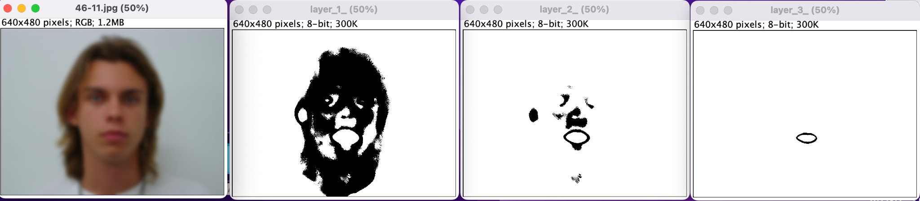

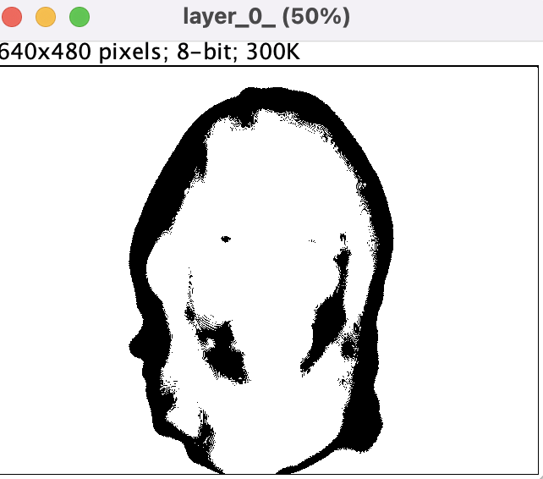

Here, it’s more detectable the face bounds, ears, lips, and central face.  
We can conclude that by applying different filters, we can detect facial parts more and it helps us in face detection logic. But not all filters will help, detection differences from filter to filter and from image to image, and also radius size will differ too. If we increased the radius the noises will disappear more but at some point; if the radius is too much, we will lose the efficiency.